# CS 340 README Template

*Use this template to complete your README file. When completing the template, keep the headings as they are so that your document has a clear organization. Remove the italicized prompt text after you have completed each section for a polished final document.*

## About the Project/Project Title

This project delivers a full-stack software application designed for Grazioso Salvare, a rescue-animal training company. The application comprises two main components:

AnimalShelter CRUD Module: A Python-based module that interfaces with a MongoDB database to manage animal records. It provides Create, Read, Update, and Delete (CRUD) operations, allowing for efficient data management of animal information.

Client-Facing Dashboard: A web-based application built using Dash (Python framework) that provides a user-friendly interface for Grazioso Salvare staff to access and interact with the animal data stored in the MongoDB database. The dashboard includes interactive features such as filtering, sorting, pagination, data visualization (pie charts), and geolocation mapping to assist in identifying and categorizing available dogs.

## Motivation

identifying dogs with the potential for search-and-rescue training is a core component of Grazioso Salvare's mission. This project aims to provide them with a tool for effectively analyzing incoming data and pinpointing promising candidates. To achieve this, the application addresses several key needs. First, it enables efficient data analysis, allowing Grazioso Salvare to quickly process and analyze large datasets from partner shelters, identifying dogs with traits suitable for search-and-rescue work, such as specific breeds, ages, and temperaments. Second, it facilitates targeted candidate identification by providing tools for targeted searches and filtering based on relevant criteria, streamlining the process of finding potential candidates. Third, by providing a clear and organized view of the data, the application improves candidate selection, helping Grazioso Salvare make more informed decisions about which dogs to select for training and maximizing their chances of success.

## Getting Started

*Note 1: this app was created to work with a preexisting, populated database that requires user authentication before access. As such, the CRUD application contains authentication variables associated with that specific instance of MongoDB. Please see step 3.*

Follow these steps to reproduce this program on your own:

1. Clone the repository  
   First, clone the repository containing the project files to your local machine:

git clone <https://github.com/yourusername/AnimalShelter.git>

1. Install required dependencies  
   Make sure you have Python 3 installed. Then, install the necessary dependencies, including the pymongo library:

*pip install pymongo*

1. Set up your MongoDB instance

If you don’t already have MongoDB installed locally, you can follow the official MongoDB installation guide to set it up: https://www.mongodb.com/docs/manual/installation/

Alternatively, you can use a cloud-based MongoDB instance, such as MongoDB Atlas.

Next, import your CSV file that you will be working with. Below you can see an instance of an import made using the MongoDB import tool.

Then, set up a user account in the mongo shell to ensure user authentication in the database you have created.

Note: Be sure to replace the USER, PASS, HOST, PORT, DB, and COL values in the code with your specific MongoDB connection details when creating your python module (username, password, host address, port number, database name, and collection name).

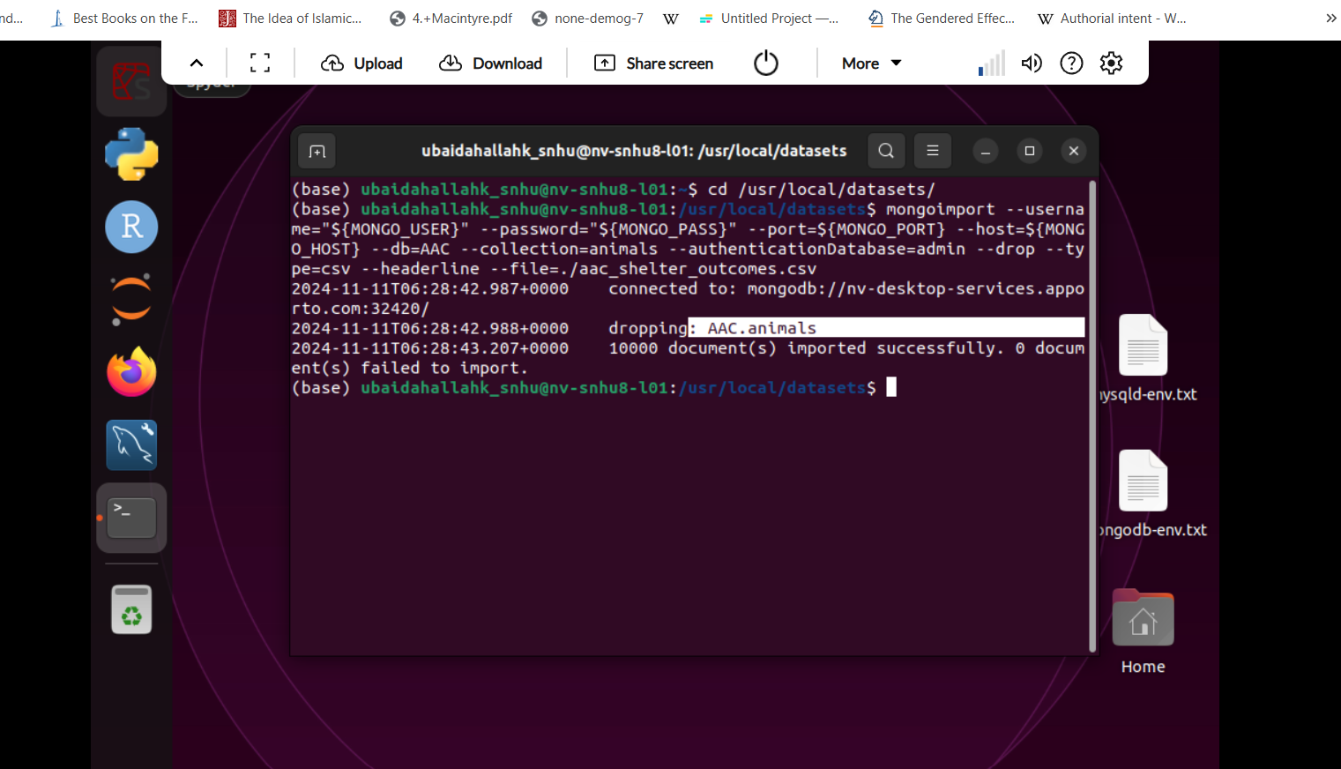

Figure 1: inserting CSV file

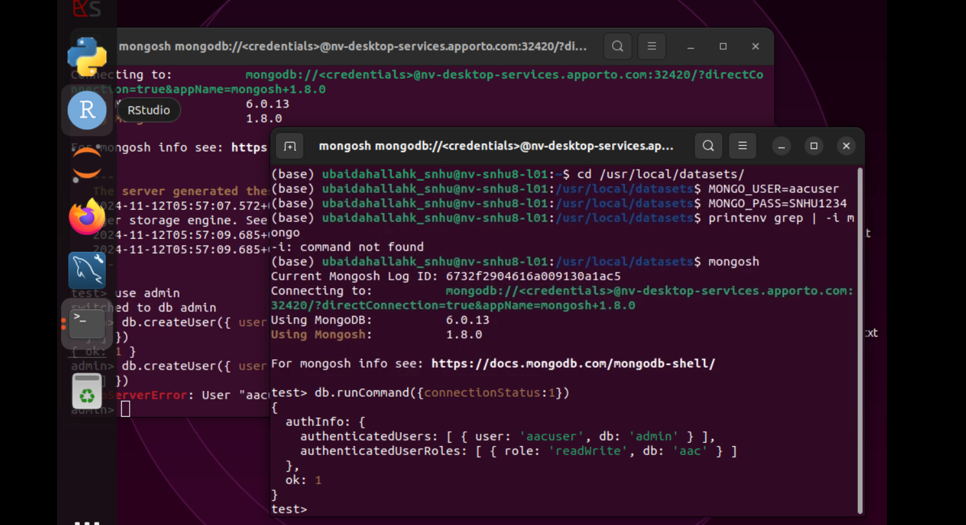

Figure 2: creating user authentication to the DB and collection

1. Run the Jupyter Notebooks (Optional):

Open a terminal in the project directory.

Start a Jupyter Notebook server using:

Bash

*jupyter notebook*

1. **Run the Dash Dashboard:**

Open a terminal or command prompt and navigate to the project directory (where your CRUDAPP.py file is located).

Before running the app, make sure you have installed all the necessary dependencies, including dash, dash-bootstrap-components, pandas, **and especially plotly for creating chart**s.

You can install them individually:

Bash

*pip install dash dash-bootstrap-components pandas plotly*

*Note 2: For the "Create" method, I designed it to insert a new animal document into the MongoDB database using the insert_one() method. A key challenge was ensuring that the method handled empty data gracefully and returned accurate success/failure responses. The "Read" method implements the find() function to query the database. The challenge here was managing the MongoDB cursor properly, converting it into a list, and handling errors when no data matched the query. To address this issue, the app uses exception handling.*

## Installation

*List the tools you need to use the software and how to install them.*

For this this CRUD app you will need:  
  
1. Python

Ensure you have Python 3.x installed on your machine. You can check this by running the following command in your terminal or command prompt: python –version

If Python is not installed, you can download and install it from the official website: <https://www.python.org>

2. MongoDB

MongoDB is the NoSQL database used for storing data. To install MongoDB locally, follow the instructions based on your operating system:

* Windows: [Install MongoDB on Windows](https://www.mongodb.com/docs/manual/tutorial/install-mongodb-on-windows/)
* macOS: [Install MongoDB on macOS](https://www.mongodb.com/docs/manual/tutorial/install-mongodb-on-os-x/)
* Linux: [Install MongoDB on Linux](https://www.mongodb.com/docs/manual/installation/)

3. Pymongo

To interact with MongoDB from Python, you will need to install the pymongo library. This can be done using pip, Python's package installer.

Open your terminal (or command prompt) and run the following command: pip install pymongo

4. bson

To handle ObjectId in MongoDB (such as when querying documents), you will also need to install the bson library. It is normally included with pymongo, but in case it's not, you can install it separately via the terminal: pip install bson

5. Jupyter Notebook (Optional): If you want to use the Jupyter Notebooks for data exploration and analysis, install the jupyter package using:

Bash

*pip install jupyter*

6. Dash (Optional): If you want to run the interactive Dash dashboard, install the Dash and dash-bootstrap-components libraries using:

Bash

*pip install dash dash-bootstrap-components*

* These libraries are required for building the web-based dashboard application.

## Usage

### Code Examples

Create function:

*def create(self, data):*

*if data is not None:*

*try:*

*result = self.database.animals.insert_one(data) # data should be dictionary*

*if result.acknowledged:*

*return True*

*else:*

*return False*

*except Exception as e:*

*print(f"Error inserting document: {e}")*

*return False*

*else:*

*raise Exception("Nothing to save, because data parameter is empty")*

Here is the create function from the CRUD app. The function checks if the data type is not none, and then returns either true or false if the data was inserted successfully. If the data is None, it is cught by the catch block.

Update function:

def update(self, dbquery, dbupdate):

try:

# Check if the inputs are valid (non-empty dictionaries)

if not dbquery or not isinstance(dbquery, dict):

raise ValueError("dbquery must be a non-empty dictionary")

if not dbupdate or not isinstance(dbupdate, dict):

raise ValueError("dbupdate must be a non-empty dictionary")

# Perform the update operation

result = self.collection.update_many(dbquery, dbupdate)

# Check if any documents were modified

if result.modified_count > 0:

return result.modified_count

else:

return "No record found matching the query"

except ValueError as ve:

print(f"ValueError: {ve}")

return 0 # Return 0 to indicate no documents were updated

except Exception as e:

print(f"Error occurred while updating documents: {e}")

return 0 # Return 0 to indicate no documents were updated

The update method is designed to update multiple documents in a MongoDB collection based on a query (dbquery) and an update operation (dbupdate). It first validates that both dbquery and dbupdate are non-empty dictionaries, raising a ValueError if they are not. The method then performs the update operation using update_many, checks if any documents were modified, and returns the number of updated documents. If no documents match the query or are updated, it returns the message "No record found matching the query". Exception handling is included to print errors and return 0 in case of invalid input or other issues during the update.

### Tests

*Describe and show how to run the tests with code examples.*

This application has been tested using Juypter notebook. To make a similar test, import your python module and class using “from YOURMODULE import YOURCLASS”.

Create an instance of your class and then the object you want to insert with your key/value pairs.

Call the function you want to test with that object, assigning it to a new variable.

Make sure to print that variable to check if the test passed or failed. An example is shown below:

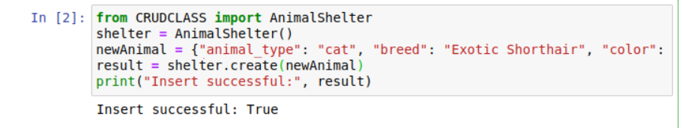

Here is a test that has been designed to fail to test the exception capturing with the insert function:  
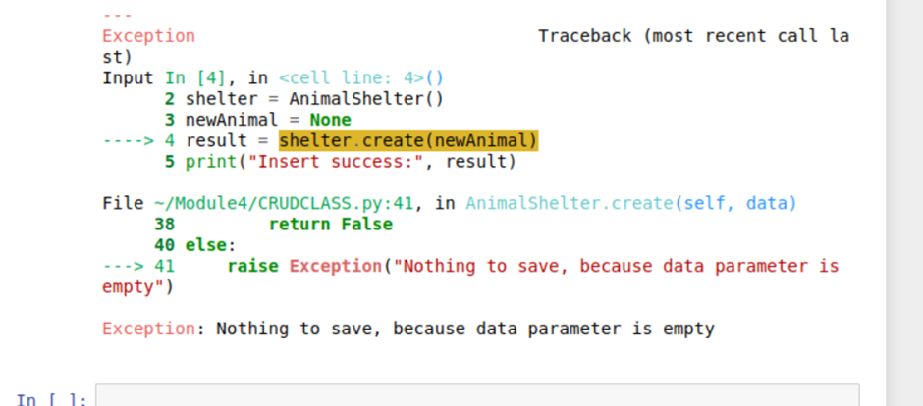

As you can see, when the NewAnimal variable is assigned with None, the exception capturing of the insert function correctly returns an exception and nothing is inserted.

Here is a test of the update functionality:

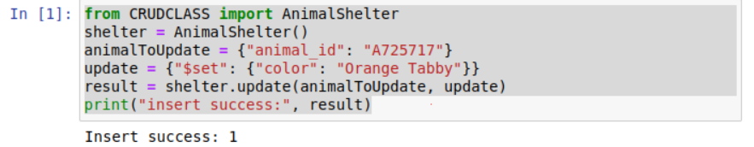  
The update has been successfully applied and the number of updates made is returned.   
  
Here’s a test of the update methods exception catching:  
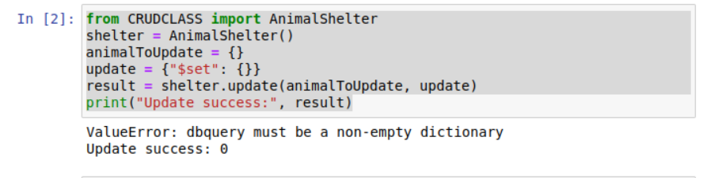  
  
When the first dictionary parameter (animal to update) is empty, the error message is returned and the number of updates is 0.

Screenshot of delete functionality:  
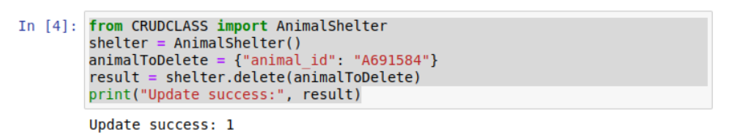  
As you can see, the delete is successful and the number of deletions is returned.

This code builds a webpage layout for a dashboard. It displays a logo, title, filtering options, and a data table. The table allows features like sorting, filtering, and pagination. There's also a section with space for two charts (pie chart and potentially a map) to be displayed side-by-side:

app.layout = html.Div([

logo_image,

html.Center(html.B(html.H1('CS-340 Dashboard'))),

html.Hr(),

html.Div(children=[unique_identifier]),

html.Div(

[

dcc.RadioItems(

id="filter-type",

options=[

{"label": "Water Rescue", "value": "water_rescue"},

{"label": "Mountain Rescue", "value": "mountain_rescue"},

{"label": "Disaster Rescue", "value": "disaster_rescue"},

{"label": "Reset", "value": "all"},

],

value="all",

)

],

style={"display": "flex", "justify-content": "center", "margin-bottom": "10px"},

),

html.Hr(),

dash_table.DataTable(id='datatable-id',

columns=[{"name": i, "id": i, "deletable": False, "selectable": True} for i in df.columns],

data=df.to_dict('records'),

sort_action='native',

filter_action='native',

page_action='native',

page_current=0,

page_size=10,

row_selectable='single',

selected_rows=[],

style_table={'overflowX': 'auto'},

editable=True,

style_data_conditional=[

{'if': {'row_index': 'odd'}, 'background_color': 'rgb(248, 248, 248)'},

{'if': {'column_id': 'some_column'}, 'background_color': '#D2F3FF', 'fontWeight': 'bold'}

]

),

html.Br(),

html.Hr(),

html.Div(className='row', style={'display' : 'flex'}, children=[

html.Div(id='graph-id', className='col s12 m6', children=[dcc.Graph(id='pie-chart')]),

html.Div(id='map-id', className='col s12 m6')

])

])

Below is a screencast of the dashboard and respective widgets in use:



## Contact

Your name: Adam Kramez